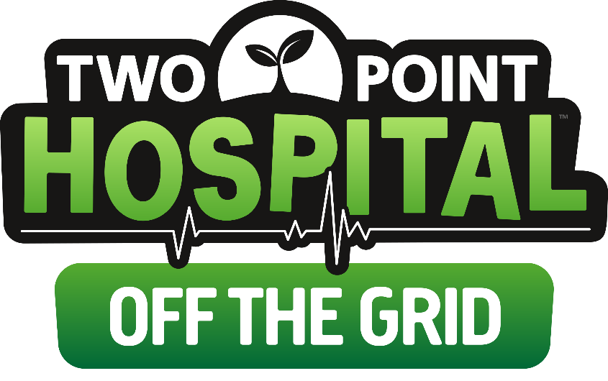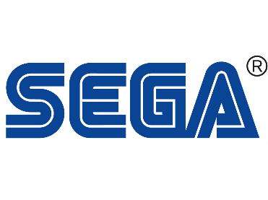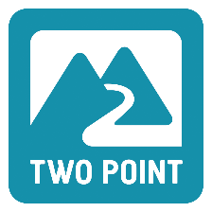

**THINK GREEN, ACT GREEN**

New Two Point Hospital expansion goes *Off the Grid* on Steam 18 March 2020

**London, England – 11 March 2020** – SEGA® Europe Ltd. and Two Point Studios™ Ltd. are pleased to reveal that the new expansion *‘Off the Grid’* is joining Two Point Hospital™ [on Steam](https://store.steampowered.com/app/1196150/), on 18 March 2020 for £6.99 and is available for pre-purchase now, with an early adopter discount of 10% until 25 March 2020. Give green a chance in Two Point Hospital and find out what you could achieve, in this brand-new trailer: <https://youtu.be/m5arzc7z3Ak>

In Two Point County, voter research has repeatedly suggested that the public’s number one concern is with the environment. To secure her place in office… ahem, we mean, to support the green-minded community, Two Point County’s ever-present mayor, Tabitha Windsock, founded the ‘Department of Green Things’. She recently discovered it pays to go green in this time of poor voter polling, so why not join the mayor on her journey to ecological (polling) victory in Two Point Hospital – Off the Grid.

In Two Point Hospital – Off the Grid you’ll explore three new regions each with its own unique characteristics. Help make Two Point County a beautiful and sustainable place to live, by researching 35 brand-new unusual illnesses (9 visual), like Green Fingers and Root Snoot, and experiencing exciting treatment rooms on your route to eco-friendly success. Get gardening to treat the region’s most herbaceous afflictions, before moving on to Windsock City, the County’s first eco-city, where you’ll need to build green energy machines to stay switched-on and self-sufficient. Generated power can be used to open hospital rooms or allocated to the Patient Flow and Staff Applicants systems, to influence transport in and out of the city.

For new players, the [‘Complete Your Set’ Bundle](https://store.steampowered.com/bundle/12440/Two_Point_Hospital_Healthy_Collection_Vol_2) is currently on offer on Steam, which gives a 10% discount to the base game and all previous DLC, Bigfoot, Pebberley Island and Close Encounters between 11 – 31 March 2020. Players will also be able to buy the ‘[Exhibition Items Pack’](https://store.steampowered.com/app/1144500/) from 18 March for £2.99, including 30 new in-game items. Two Point Hospital – Off the Grid will only be available on Steam; for more information on all things Two Point Hospital, sign up for our Hospital Pass newsletter at [www.twopointhospital.com](http://www.twopointhospital.com/) where you will receive the coveted in-game item, the Golden Bathroom Suite. You can also follow the game on [YouTube](https://www.youtube.com/channel/UCyM2ggE_7Ttc8h0ecy65_mw/featured), [Facebook](https://www.facebook.com/twopointhospital/) and [Twitter](http://www.twitter.com/2PointHospital). For more information about SEGA Europe, log on to [www.sega.co.uk](http://www.sega.co.uk/), follow us on [Facebook](http://www.facebook.com/sega) or on [Twitter](http://www.twitter.com/sega).

**About Two Point Studios Ltd.**

Two Point Studios Ltd. is a British game developer, based in Farnham, Surrey (UK) and was founded in 2016. Two Point Studios’ small, but dedicated and passionate team have worked on some of the most recognisable brands in gaming, including Fable and Black and White. Drawing on that experience, Two Point Studios released a brand-new IP in the sim genre called Two Point Hospital, which launched for PC in August 2018. For more information about Two Point Studios visit [www.twopointstudios.com](http://www.twopointstudios.com/).

**About SEGA® Europe Ltd.:**

SEGA Europe Ltd. is the European Distribution arm of Tokyo, Japan-based SEGA Games Co., Ltd., and a worldwide leader in interactive entertainment both inside and outside the home. The company develops and distributes interactive entertainment software products for a variety of hardware platforms including PC, wireless devices, and those manufactured by Nintendo, Microsoft and Sony Interactive Entertainment Europe. SEGA wholly owns the video game development studios Two Point Studios, Creative Assembly, Relic Entertainment, Amplitude Studios, Sports Interactive and Hardlight. SEGA Europe’s website is located at [www.sega.co.uk](http://www.sega.co.uk)